**EXPERIMENT-1**

**By: Amogh Garg**

**AIM**: To design and construct RC differentiator and RC integrator circuit and study its frequency response of RC differentiator as high pass filter and RC integrator circuit as low pass filter.

**SOFTWARE:**LT Spice XVII

**THEORY: 1) RC Differentiator:**

An RC differentiator circuit is a wave shaping circuit. It constitutes a capacitor in series and a resistor in parallel at the output. The time constant (R x C) of the circuit is very small in comparison with the period of the input signal. As the name shows the circuit does the mathematical operation ‘differentiation’ on the input signal. At the time of differentiation the voltage drop across R will be very small in comparison with the drop across C.

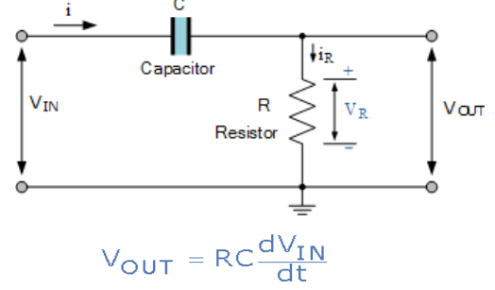

The output voltage, VOUT is the derivative of the input voltage, V IN which is weighted by the constant of RC, where RC represents the time constant.

**OBSERVATION/RESULT:**

1) Square Wave Input-

Circuit-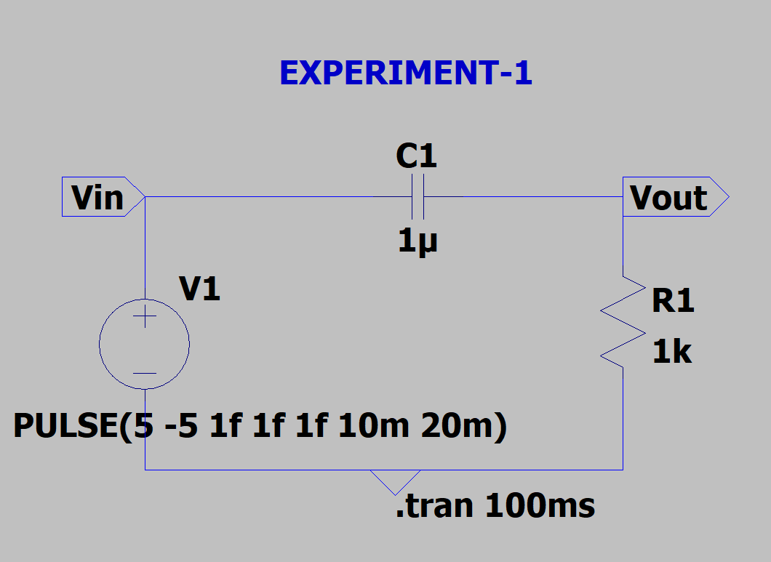

Output-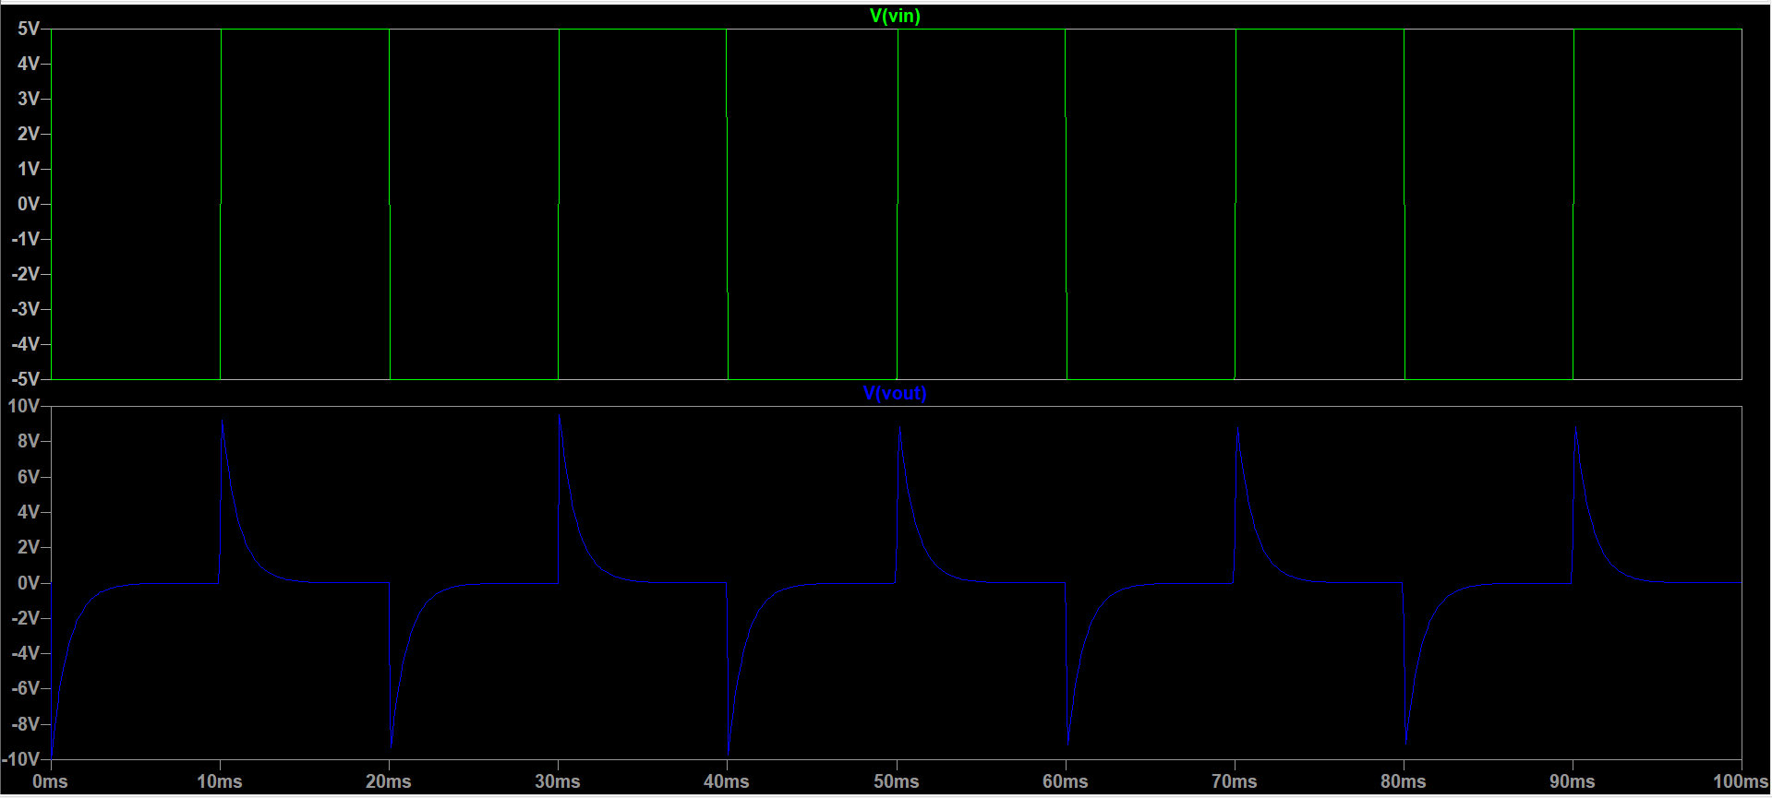

2)Triangular Wave Input: Circuit-

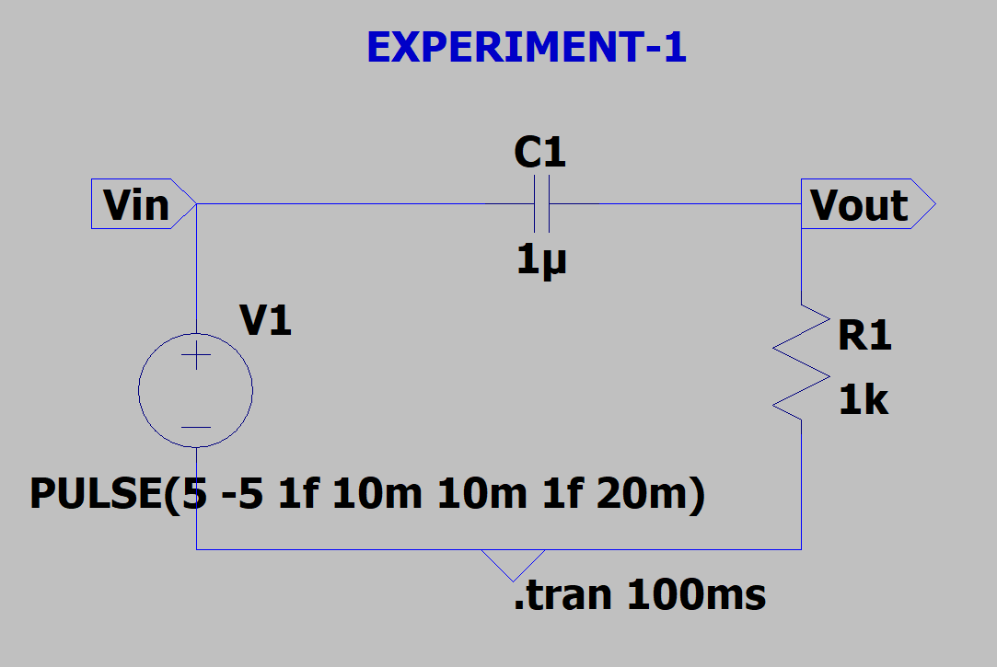

Output-

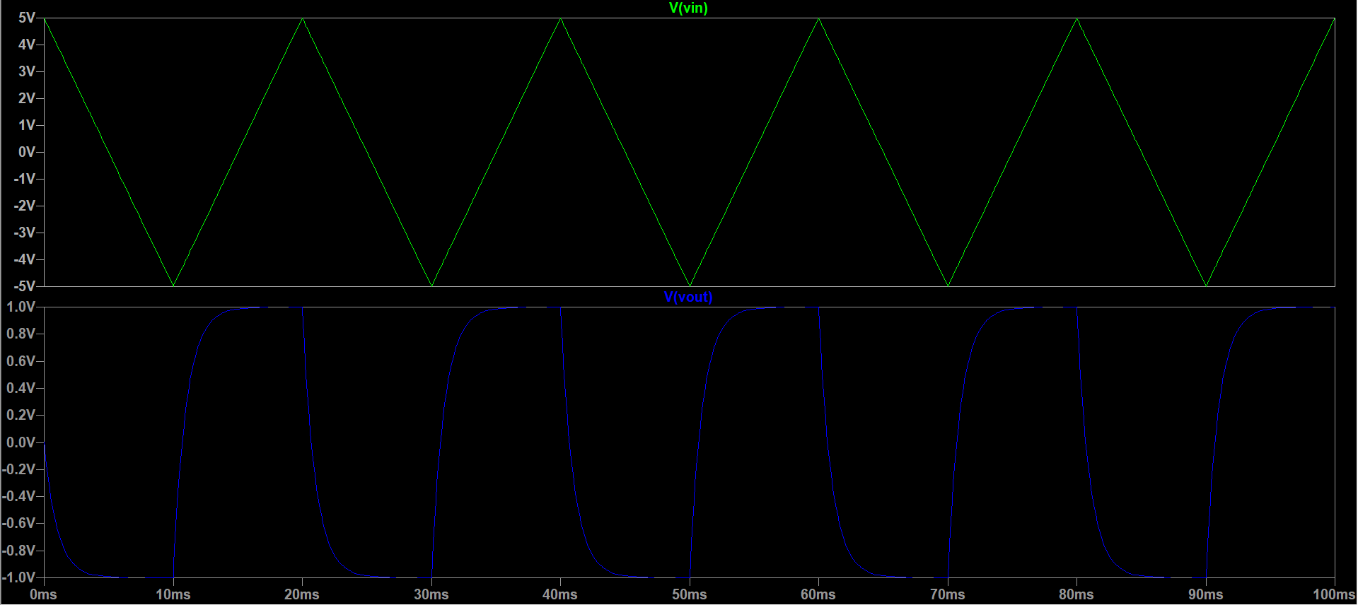

3) Frequency response of differentiator of circuit as high pass filter:

Circuit-

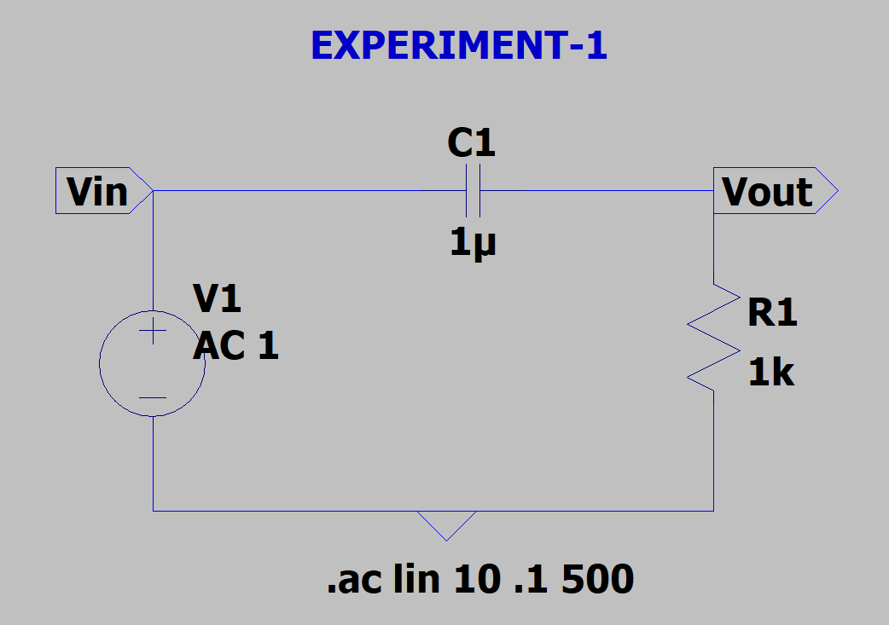

Output-

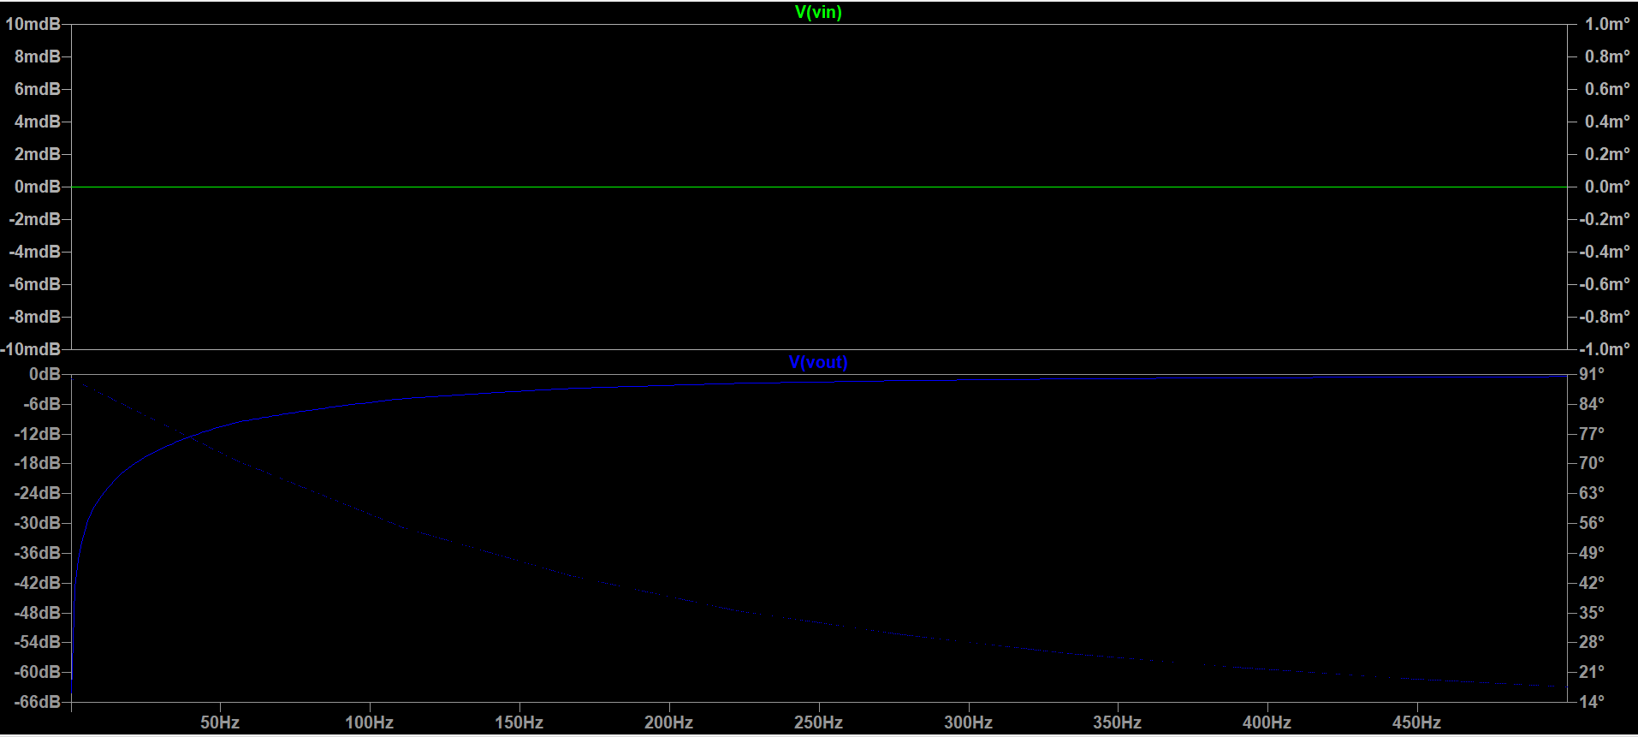

**2)RC INTEGRATOR:**1) Square Wave Form:

Circuit:

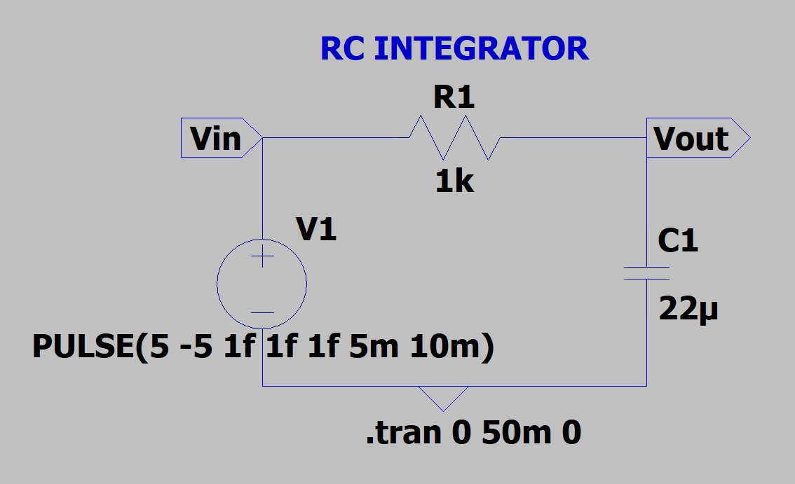

Output:

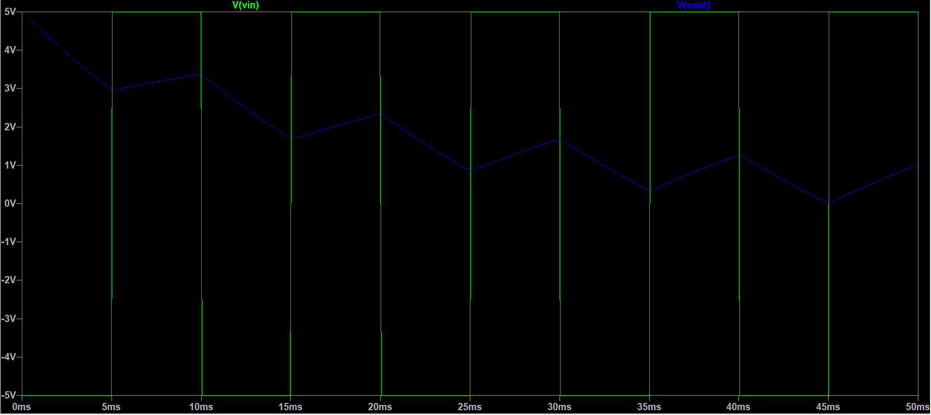

2)AC Sweep: Circuit-

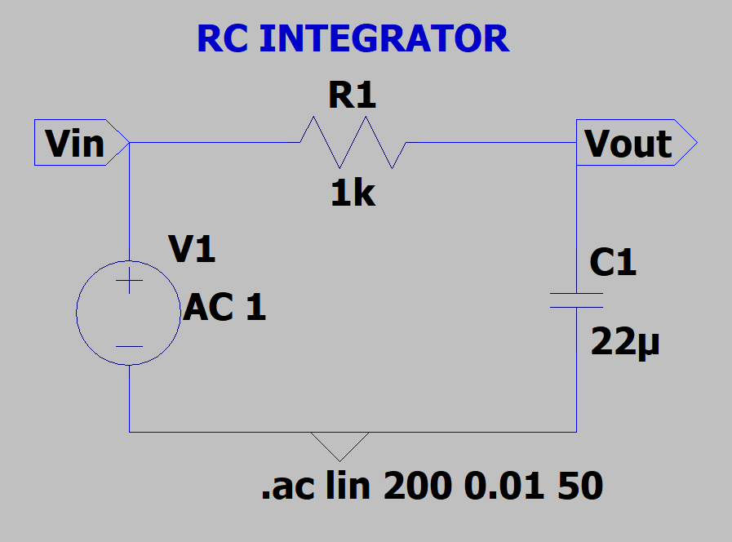

Output:

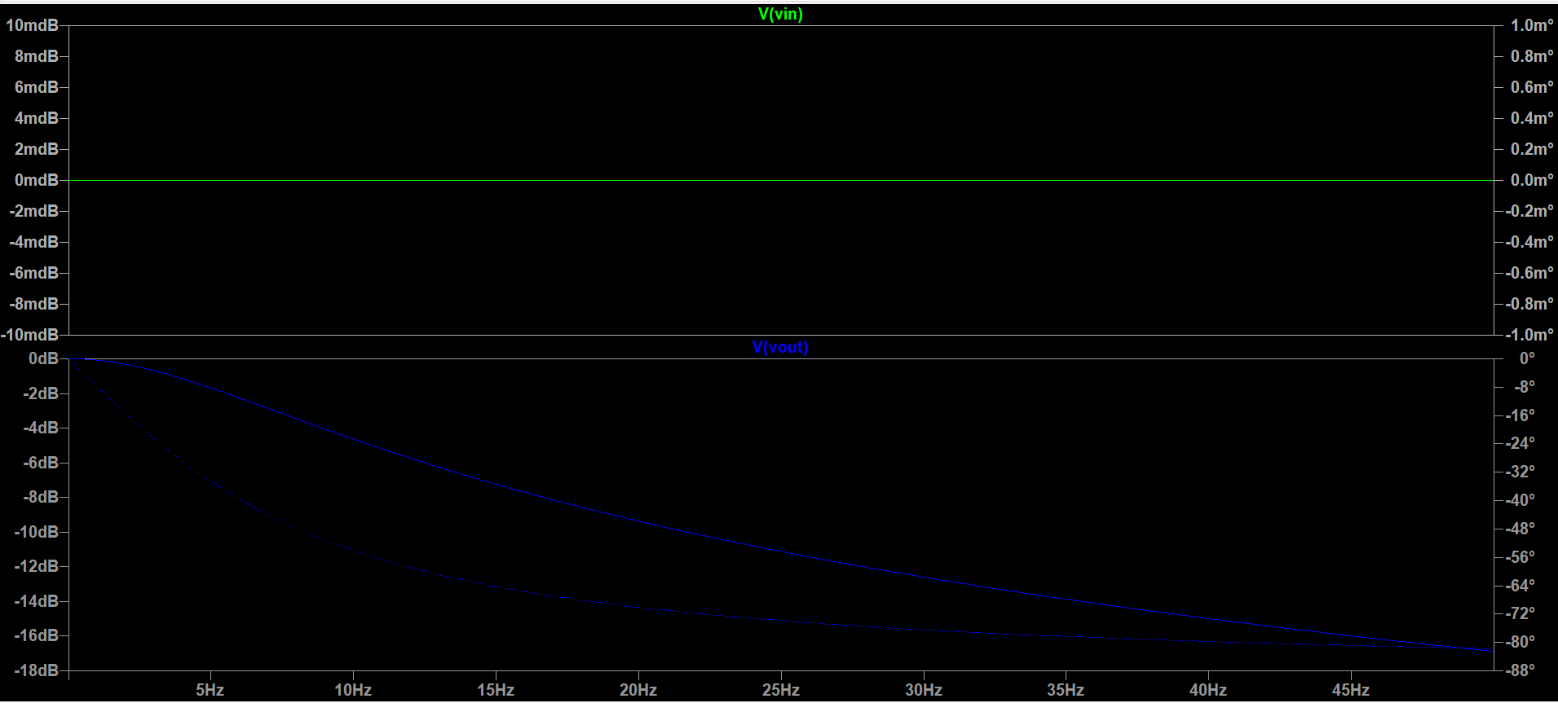

**BY: AMOGH GARG**

**2020UCO1688**

**COE(SECTION-3)**